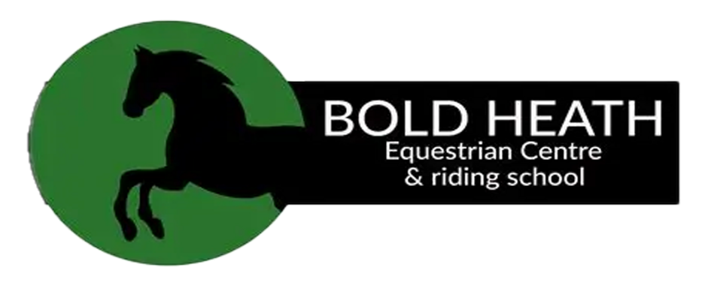

Working Hunter Series Show

1st November 2026

Venue – Bold Heath Equestrian Centre,
WA8 3XT

Start time 9am
Judge – Victoria Whalley

Class 0 Clear Round – 30cm cross pole
Class 1 Tiny Tots Lead Rein Workers – Rider to be 10 years and under. Max height of jumps 30cm. 6 fences in course max.
Class 2 True Beginners Workers - Horse/pony to be 4 years and over. Rider any age. Rider to be suitable size for horse/pony. Height max height 40cm cross poles. Max 8 jumps.
Class 3 Mini Workers – Rider 13 years and under. Max height of jumps 50cm cross poles.
Class 4 Junior Workers – Rider 16 years and under. Max height of jumps 50cm.
Class 5 Novice Workers – Horse/pony to be 4 years and over. Rider any age. Rider to be suitable size for horse/pony. Height max height 50cm.
Clear Round – Horse/pony to be 4 years and over. Rider any age. Rider to be suitable size for horse/pony. Height max height 50cm.
Class 6 Working Hunter Series 50cm – Open to plaited and non-plaited horse/pony. Rider any age to be suitable size for horse/pony. Horse/pony to be 4 years and over. Jumps not to exceed 50cm.

Lunch Break – 30 minutes – Classes below not before time 1pm
Class 7 Working Hunter Series 60cm – Open to plaited and non-plaited horse/pony. Rider any age to be suitable size for horse/pony. Horse/pony to be 4 years and over. Jumps not to exceed 60cm.
Class 8 Working Hunter Series 70cm – Open to plaited and non-plaited horse/pony. Rider any age to be suitable size for horse/pony. Horse/pony to be 4 years and over. Jumps not to exceed 70cm.
Class 9 Working Hunter Series 80cm – Open to plaited and non-plaited horse/pony. Rider any age to be suitable size for horse/pony. Horse/pony to be 4 years and over. Jumps not to exceed 80cm.
Class 10 Working Hunter Series 90cm – Open to plaited and non-plaited horse/pony. Rider any age to be suitable size for horse/pony. Horse/pony to be 4 years and over. Jumps not to exceed 90cm.
Class 11 Working Hunter Series 100cm – Open to plaited and non-plaited horse/pony. Rider any age to be suitable size for horse/pony. Horse/pony to be 4 years and over. Jumps not to exceed 100cm.



Official Photographer for the Venue

Rules / Information
- Pre Entry £13 per class
- Entry on the Day £15 per class

- Entries on the day are CASH ONLY

- Cafe open all day – CASH ONLY

- Lottie Christian Photography Official Photographer www.lottiechristianphotography.co.uk

- Stables available - £15 per stable, £10 cash returnable deposit post mucking out required – please message page to book or can get on the day if any left

- Annual Vaccinations required – horse/pony must have had the first 2 vaccinations and be 6 days clear from any vaccination

- Please ensure you are wearing correct attire for your class. No mobile phones to be in jodphurs

- Judges’ decision is final. We will not accept any rudeness towards any of the judges/stewards/photographers/parking attendance or any other of the team

- Back numbers must be displayed correctly and clear

- Gloves and hats to be always worn when riding your horse or pony

- Lead rein handler to ensure hat of suitable type is worn, not required to be a hard hat

- Bedding and poo to be picked up and you are responsible for removing this from carparks.

- Spurs are not to be used on under 16s

- Martingales are allowed

